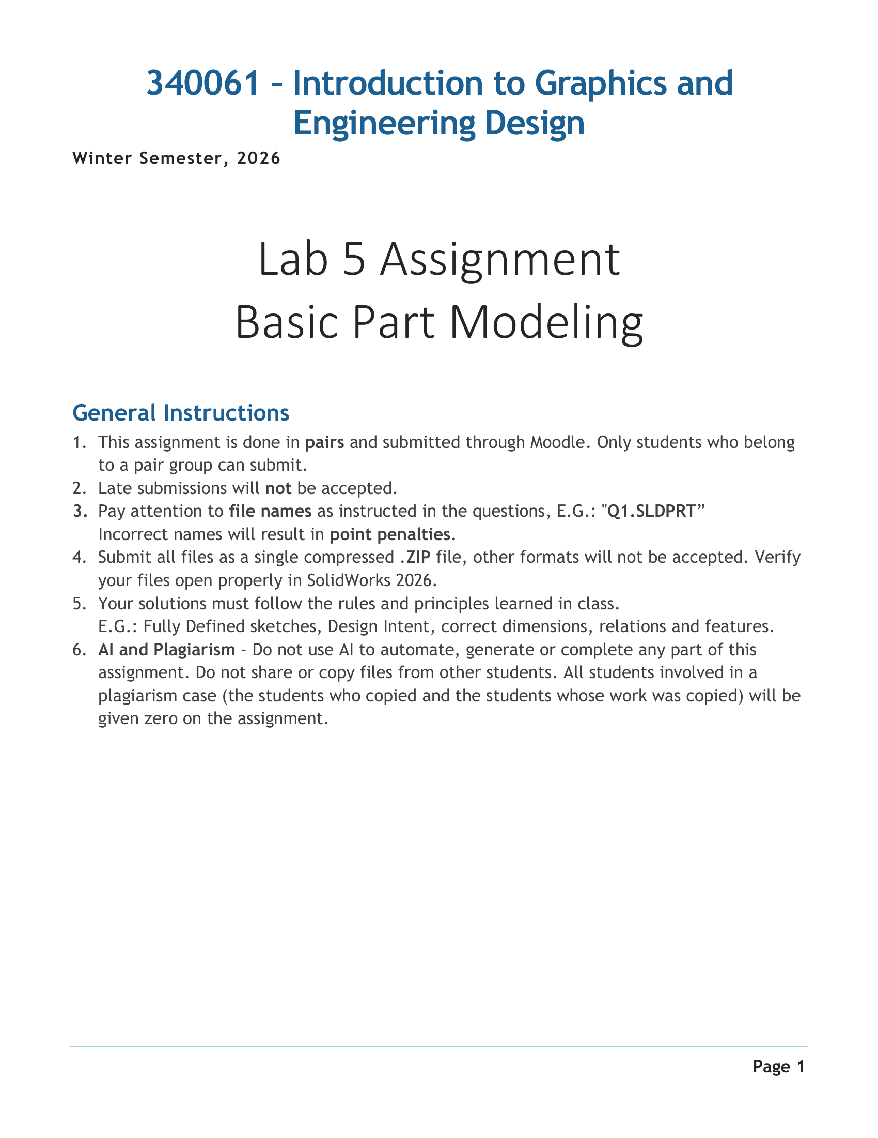

LAB 5 / BASIC PART MODELING

General Instructions / 通用说明
中英对照 · 对应原文第 1 页 / Bilingual companion to source page 1
340061 – Introduction to Graphics and Engineering Design
340061 — 图形学与工程设计导论
Winter Semester, 2026
2026 年冬季学期
Lab 5 Assignment · Basic Part Modeling
Lab 5 作业 · 基础零件建模
1. This assignment is done in pairs and submitted through Moodle. Only students who belong to a pair group can submit.
1. 本作业须两人一组完成，并通过 Moodle 提交。只有已加入两人小组的学生才能提交。
2. Late submissions will not be accepted.
2. 不接受逾期提交。
3. Pay attention to file names as instructed in the questions, E.G.: “Q1.SLDPRT”. Incorrect names will result in point penalties.
3. 请按各题要求正确命名文件，例如“Q1.SLDPRT”。文件名不正确将被扣分。
4. Submit all files as a single compressed .ZIP file, other formats will not be accepted. Verify your files open properly in SolidWorks 2026.
4. 将所有文件打包为一个 .ZIP 压缩文件提交；不接受其他压缩格式。请确认文件能在 SolidWorks 2026 中正常打开。
5. Your solutions must follow the rules and principles learned in class. E.G.: Fully Defined sketches, Design Intent, correct dimensions, relations and features.
5. 解答必须遵循课堂所学的规则与原则，例如：草图完全定义、体现设计意图，以及使用正确的尺寸、几何关系和特征。
6. AI and Plagiarism – Do not use AI to automate, generate or complete any part of this assignment. Do not share or copy files from other students. All students involved in a plagiarism case (the students who copied and the students whose work was copied) will be given zero on the assignment.
6. AI 与抄袭：不得使用 AI 自动执行、生成或完成本作业的任何部分。不得与其他学生共享文件或抄袭其文件。凡涉及抄袭的学生，无论是抄袭者还是作品被抄袭者，本作业均记零分。

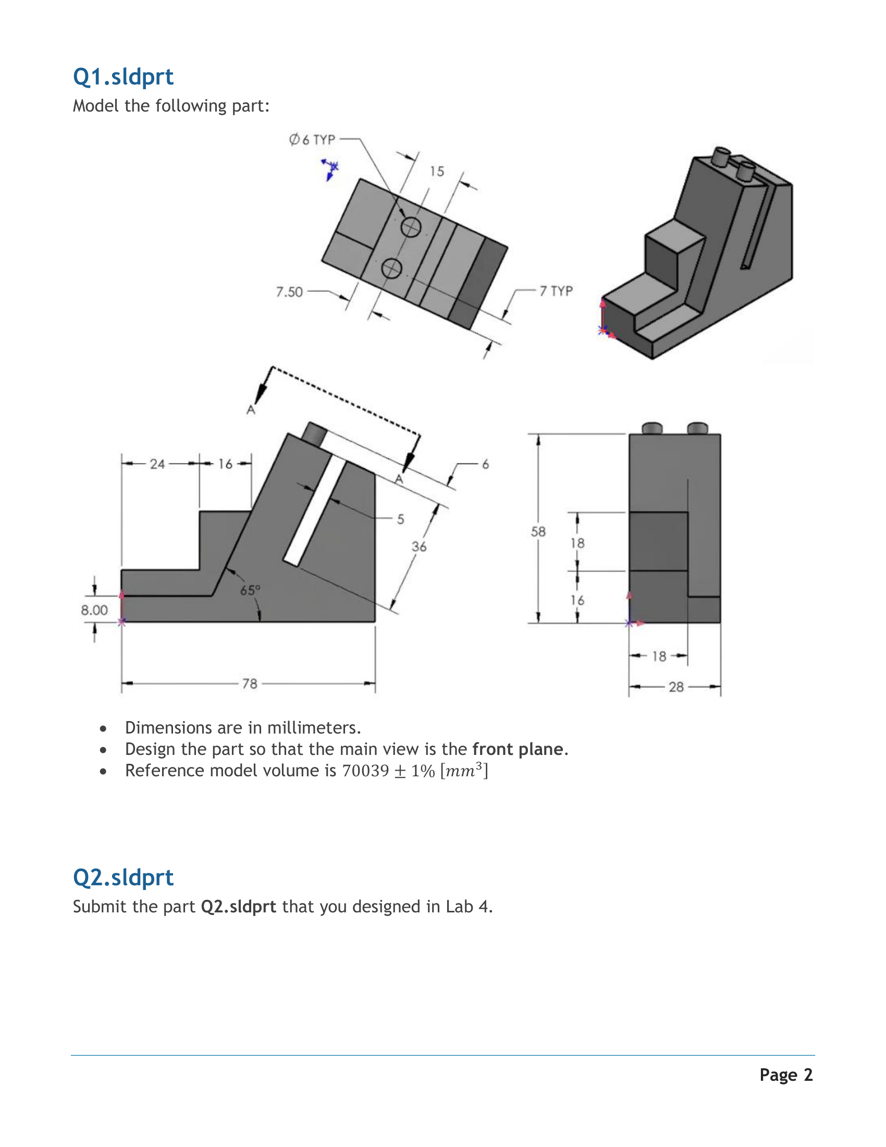

LAB 5 / BASIC PART MODELING

Q1.sldprt + Q2.sldprt / 第 1、2 题
中英对照 · 对应原文第 2 页 / Bilingual companion to source page 2
Q1.sldprt — Model the following part.
Q1.sldprt — 建立原图所示零件的三维模型。
Dimensions are in millimeters.
尺寸单位为毫米。
Design the part so that the main view is the front plane.
建模时，使主视图对应前视基准面 / Front Plane。
Reference model volume is 70039 ± 1% [mm³].
模型参考体积为 70039 mm³，允许偏差为 ±1%。
Q2.sldprt — Submit the part Q2.sldprt that you designed in Lab 4.
Q2.sldprt — 提交你在 Lab 4 中设计的零件 Q2.sldprt。

Figure labels / 图内文字
TYP = typical / 同类位置均适用；Ø6 TYP = 同类圆柱或圆孔均为直径 6；7 TYP = 同类位置尺寸均为 7；A–A = section designation / A–A 剖切标识。

Reading note / 读图提示
图形、尺寸值、红色原点和视图完整保留在前一页原图中。Q2 的要求为沿用 Lab 4 的同名零件，并非新建本页 Q1。 / The preceding original page retains the complete geometry, dimensions, red origin and views. Q2 reuses the named Lab 4 part; it is separate from Q1.

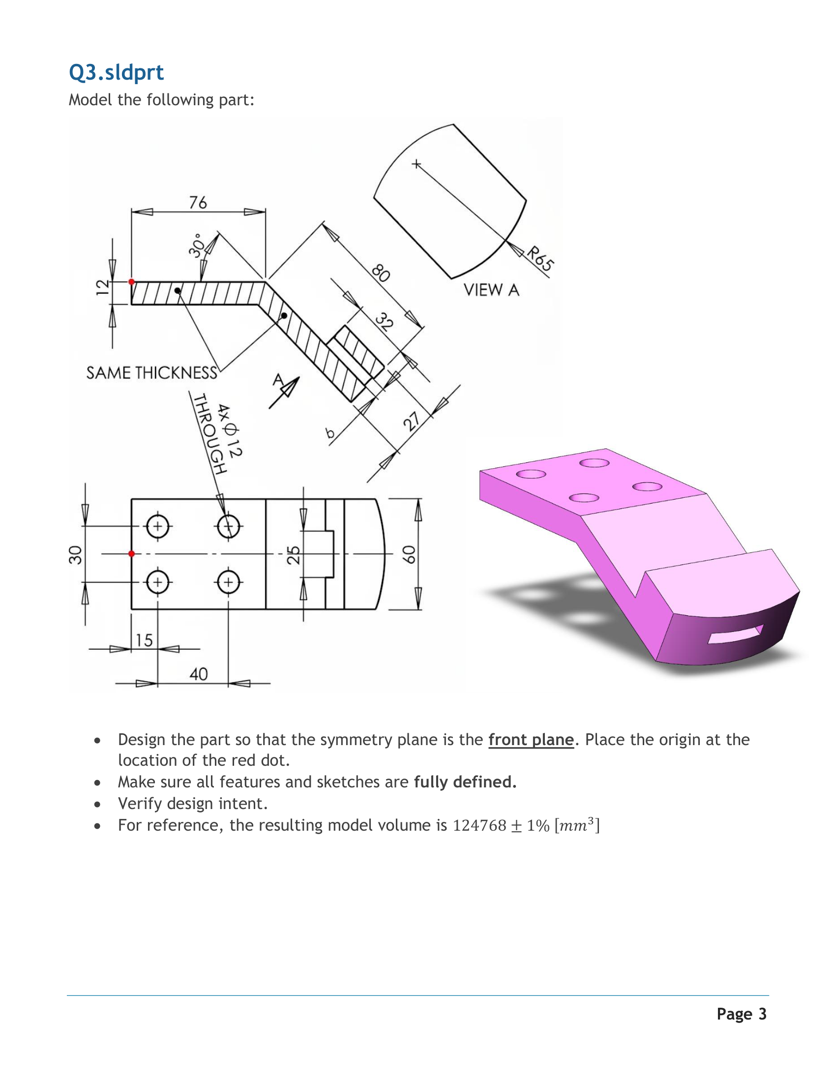

LAB 5 / BASIC PART MODELING

Q3.sldprt / 第 3 题
中英对照 · 对应原文第 3 页 / Bilingual companion to source page 3
Model the following part.
建立原图所示零件的三维模型。
Design the part so that the symmetry plane is the front plane. Place the origin at the location of the red dot.
建模时，使对称面与前视基准面 / Front Plane 重合，并将原点置于红点所示位置。
Make sure all features and sketches are fully defined.
确保所有特征和草图均完全定义 / Fully Defined。
Verify design intent.
检查模型是否体现设计意图 / Design Intent。
For reference, the resulting model volume is 124768 ± 1% [mm³].
最终模型的参考体积为 124768 mm³，允许偏差为 ±1%。

Figure labels / 图内文字
SAME THICKNESS = 厚度相同；4X Ø12 THROUGH = 4 个直径 12 的贯穿孔；VIEW A = A 向视图；R65 = 半径 65。 / “SAME THICKNESS” links the indicated equal-thickness regions. “4X Ø12 THROUGH” specifies four through holes, each of diameter 12.

Source note / 原文说明
本页题干未单列“单位为毫米”条目；上文按原文完整翻译，图上标注与参考体积单位均保留。 / The source Q3 does not contain a separate millimeter-units bullet. Its wording, drawing annotations and reference-volume units are preserved.

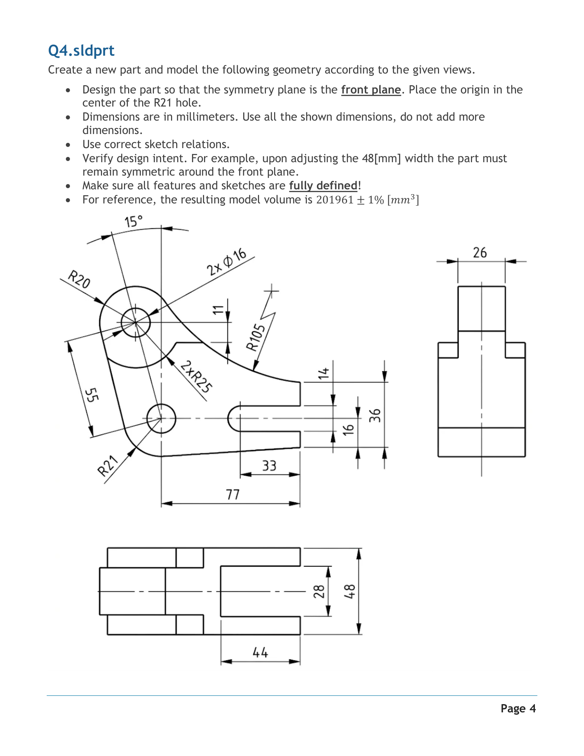

LAB 5 / BASIC PART MODELING

Q4.sldprt / 第 4 题
中英对照 · 对应原文第 4 页 / Bilingual companion to source page 4
Create a new part and model the following geometry according to the given views.
新建一个零件，并根据给定视图建立图示几何形体。
Design the part so that the symmetry plane is the front plane. Place the origin in the center of the R21 hole.
建模时，使对称面与前视基准面 / Front Plane 重合。将原点置于“R21 孔”的中心（原文表述）。
Dimensions are in millimeters. Use all the shown dimensions, do not add more dimensions.
尺寸单位为毫米。使用图中给出的全部尺寸，不得额外增加尺寸。
Use correct sketch relations.
使用正确的草图几何关系 / Sketch Relations。
Verify design intent. For example, upon adjusting the 48[mm] width the part must remain symmetric around the front plane.
检查设计意图 / Design Intent。例如，调整 48 mm 的宽度后，零件仍必须关于前视基准面 / Front Plane 对称。
Make sure all features and sketches are fully defined!
确保所有特征和草图均完全定义 / Fully Defined！
For reference, the resulting model volume is 201961 ± 1% [mm³].
最终模型的参考体积为 201961 mm³，允许偏差为 ±1%。

Translator’s note / 译注
原文使用“R21 hole”，而图中 R21 标在左下外轮廓圆弧；两个孔标注为 2×Ø16。此处原样保留原文，用图中左下孔与 R21 外圆弧的共同圆心定位原点，勿把孔径改为 R21。 / The source says “R21 hole”, while R21 labels the lower-left outer arc and the two holes are labeled 2×Ø16. The source wording is retained. Use the shared center of the lower-left hole and R21 outer arc for the origin; do not reinterpret the hole as radius 21.

Figure labels / 图内文字
2×Ø16 = two holes of diameter 16 / 两孔直径均为 16；2×R25 = two radii of 25 / 两处圆弧半径均为 25。

